

**INSTITUTE FOR**

**ADVANCED COMPUTING**

**AND SOFTWARE**

**DEVELOPMENT AKURDI,**

**PUNE**

##### DOCUMENTATION ON

“Sneakerz Store”

PG-DAC March-2023

**Submitted By**

|  |  |
| --- | --- |
| **Student Name** | **PRN No.** |
| Aniket Jaiswal | 230341220020 |
| Bhagyesh Randhawan | 230341220042 |

**Mrs. Sonali Mogal Mr. Rohit Puranik Project Guide Centre Coordinator**

**ABSTRACT**

The purpose of Sneakerz Store is to automate the existing manual system by the help of computerized equipment’s and full-fledged computer software, fulfilling their requirements, so that their valuable data/information can be stored for a longer period with easy accessing and manipulation of the same. The required software and hardware are easily available and easy to work with.

Sneakerz Store, as described above, can lead to error free, secure, reliable and fast management system. It can assist the user to concentrate on their other activities rather to concentrate on the record keeping. Thus, it will help organization in better utilization of resources. The organization can maintain computerized records without redundant entries. That means that one need not be distracted by information that is not relevant, while being able to reach the information.

The aim is to automate its existing manual system by the help of computerized equipment’s and full-fledged computer software, fulfilling their requirements, so that their valuable data/information can be stored for a longer period with easy accessing and manipulation of the same. Basically, the project describes how to manage for good performance and better services for the clients.

**ACKNOWLEDGMENT**

I take this occasion to thank God, almighty for blessing us with his grace and taking our endeavor to a successful culmination. I extend my sincere and heartfelt thanks to our esteemed guide, **Mrs. Sonali Mogal** for providing me with the right guidance and advice at the crucial juncture sand for showing me the right way. I extend my sincere thanks to our respected **Centre Co-Ordinator Mr. Rohit Puranik** for allowing us to use the facilities available. I would like to thank the other faculty members also, at this occasion. Last but not the least, I would like to thank my friends and family for the support and encouragement they have given me during the course of our work.

**Aniket Jaiswal (230341220020)**

**Bhagyesh Randhawan (230341220042)**

**Table of Contents**

1. **Introduction**...............................................................................................................................6 Problem Statement..................................................................................................................... 6

Aim & Objectives........................................................................................................................6

1. **Software Requirements Specification**.....................................................................................7
2. **System Diagram**........................................................................................................................10

Activity Diagram........................................................................................................................11

Data Flow Diagram....................................................................................................................11

Use Case Diagram ....................................................................................................................13

ER Diagram ..............................................................................................................................13

Class Diagram...........................................................................................................................14

**5. Table Structure**........................................................................................................................ 15

User ..........................................................................................................................................15

product......................................................................................................................................15

address… ..................................................................................................................................16

cart …........................................................................................................................................16

payment…...…………...............................................................................................................16

order……..………….................................................................................................................17

**6.Screenshots**……………………………………………………………………………………...18

**7.** **Conclusion**.............................................................................................................................22

Future Scope ...........................................................................................................................23

**8. References** ............................................................................................................................24

**List of Figures**

Figure 1 Activity Diagram……………................................................................................................8

Figure 2 Level 0 Data Flow Diagram ...................................................................................................9

Figure 3 Level 1 Data Flow Diagram ...................................................................................................9

Figure 4 Level 2 Data Flow Diagram...................................................................................................10

Figure 5 Class Diagram……………… ...............................................................................................11

Figure 6 Use Case Diagram ……………….........................................................................................12

Figure 7 ER Diagram ...........................................................................................................................13

# **INTRODUCTION**

**Introduction:**

The "Sneakerz Store" has been developed to override the problems prevailing in the practicing manual system. This software is supported to eliminate and, in some cases, reduce the hardships faced by this existing system. Moreover, this system is designed for the particular need of the company to carry out operations in a smooth and effective manner.

**Problem Statement:**

The application is reduced as much as possible to avoid errors while entering the data. It also provides error message while entering invalid data. No formal knowledge is needed for the user to use this system. Thus, by this all it proves it is user-friendly. Online Shoes Store, as described above, can lead to error free, secure, reliable and fast management system. It can assist the user to concentrate on their other activities rather to concentrate on the record keeping. Thus, it will help organization in better utilization of resources.

**Aims and Objective:**

Every organization, whether big or small, has challenges to overcome and managing the information of Order, Customer, Payment, Shopping Cart, Payment. Every Online Shoes Store has different Customer needs; therefore, we design exclusive employee management systems that are adapted to your managerial requirements. This is designed to assist in strategic planning, and will help you ensure that your organization is equipped with the right level of information and details for your future goals. Also, for those busy executive who are always on the go, our systems come with remote access features, which will allow you to manage your workforce anytime, at all times. These systems will ultimately allow you to better manage resources.

# **SOFTWARE REQUIREMENT SPECIFICATION**

**Purpose**:

The Sneakerz Store web application is intended to provide complete solutions for customers through a single get way using the internet. It will enable customer to browse through the shop and purchase them online without having to visit the shop physically. The administration module will enable a system administrator to maintain various lists of shop category.

**Scope**:

This system allows the customers to maintain their cart for add or remove the product over the internet based on their availability. Customer will be able to review order history and able to cancel order within 24 hours.

**Definitions**:

SS- Sneakerz Store

SRS- Software Requirement Specification GUI- Graphical User Interface

Stockholder- The person who will participate in system

Ex. Customer, Administrator, Visitor etc.

**Overview**:

This system provides an easy solution for customers to buy the product without going to the shop. This proposed system can be used by any naïve users and it does not require any educational level, experience or technical expertise in computer field but it will be of good use if user has the good knowledge of how to operate a computer.

**Overall Description:**

The Sneakerz Store (SS) application enables customers to browse through the shops, and a system administrator to maintain lists of shop categories. Also, the developer is designing an online shoes shopping site to manage the items in the shop and also help customers to purchase them online without visiting the shop physically. The Sneakerz Store will use the internet as the sole method for selling goods to its consumers.

**Product Perspective:**

This product aimed toward a person who don’t want to visit the shop as he might don’t get time for that or might not interested in visiting there and dealing with lot of formalities.

**User Characteristics:**

User should be familiar with the terms like login, register, order system etc.

**Principle Actors:**

Principle Actors are Customer and Administrator.

**General Constraints:**

A full internet connection is required for Sneakerz Store.

**Assumptions and Dependencies:**

Working of Sneakerz Store need Internet Connection.

**Specific Requirements:**

**Functional Requirements:**

This section provides requirement overview of the system.

Various functional modules that can be implemented by the system will be -

**Registration**:

If customer wants to buy the product, then he/she must be registered, unregistered user can’t go to the shopping cart.

**Login:**

Customer logins to the system by entering valid user id and password for the shopping.

**Changes to Cart:**

Changes to cart means the customer after login or registration can make order or cancel order of the product from the shopping cart.

**Payment**

In this system we are dealing the mode of payment by Cash and Online payment mode like UPI payments. We will extend this to credit card, debit card etc. in the future.

**Logout**

After ordering or surfing for the product customer has to logout.

**Non-Functional Requirements:**

* Following Non-Functional Requirements will be there in the insurance to the internet:
* Secure access to consumer’s confidential data.
* 24X7 availability.
* Better component design to get better performance at peak time.
* Flexible service-based architecture will be highly desirable for future extension. Non-Functional Requirements define system properties and constraints.

**Various other Non-Functional Requirements are:**

* Security
* Reliability
* Maintainability
* Portability
* Extensibility
* Reusability
* Compatibility
* Resource Utilization

**Performance Requirements:**

In order to maintain an acceptable speed at maximum number of uploads allowed from a particular customer as any number of users can access to the system at any time.

Also, the connections to the servers will be based on the attributes of the user like his location and server will be working 24X7 times.

**Technical Issues:**

This system will work on client-server architecture. It will require an internet server and which will be able to run PHP application. The system should support some commonly used browser such as IE, Mozilla Firefox, chrome etc.

**Interface Requirement:**

Various interfaces for the product could be-

1. Login Page
2. Registration Form
3. There will be a screen displaying information about product that the shop having.
4. If the customers select the buy button, then another screen of shopping cart will be opened.
5. After ordering for the product, the system will send one copy of the bill to the customer’s Email- address

**OPERATING ENVIRONMENT:**

**Server Side:**

**Processor:** Intel core i5 or modern

**HDD:** Minimum 500GB Disk Space

**RAM:** Minimum 8GB

**OS:** Windows 10

**Client Side (minimum requirement):**

**Processor:** Intel Dual Core

**HDD:** Minimum 80GB Disk Space

**RAM:** Minimum 4GB

**OS:** Windows 7 or above

# **SYSTEM DIAGRAMS**

* **Activity Diagram**

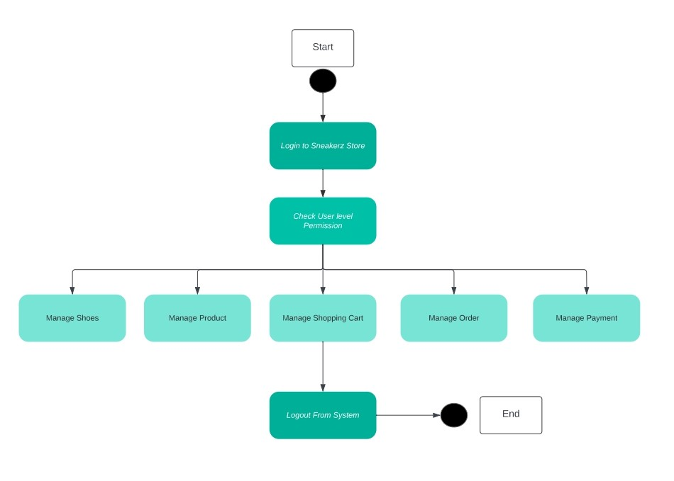

* **DFD-0 Diagram**

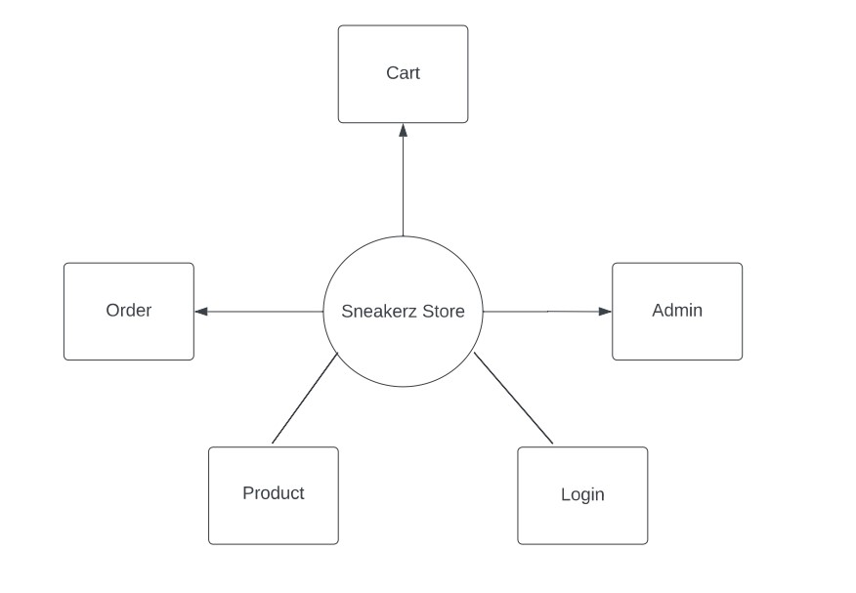

* **DFD-1 Diagram**

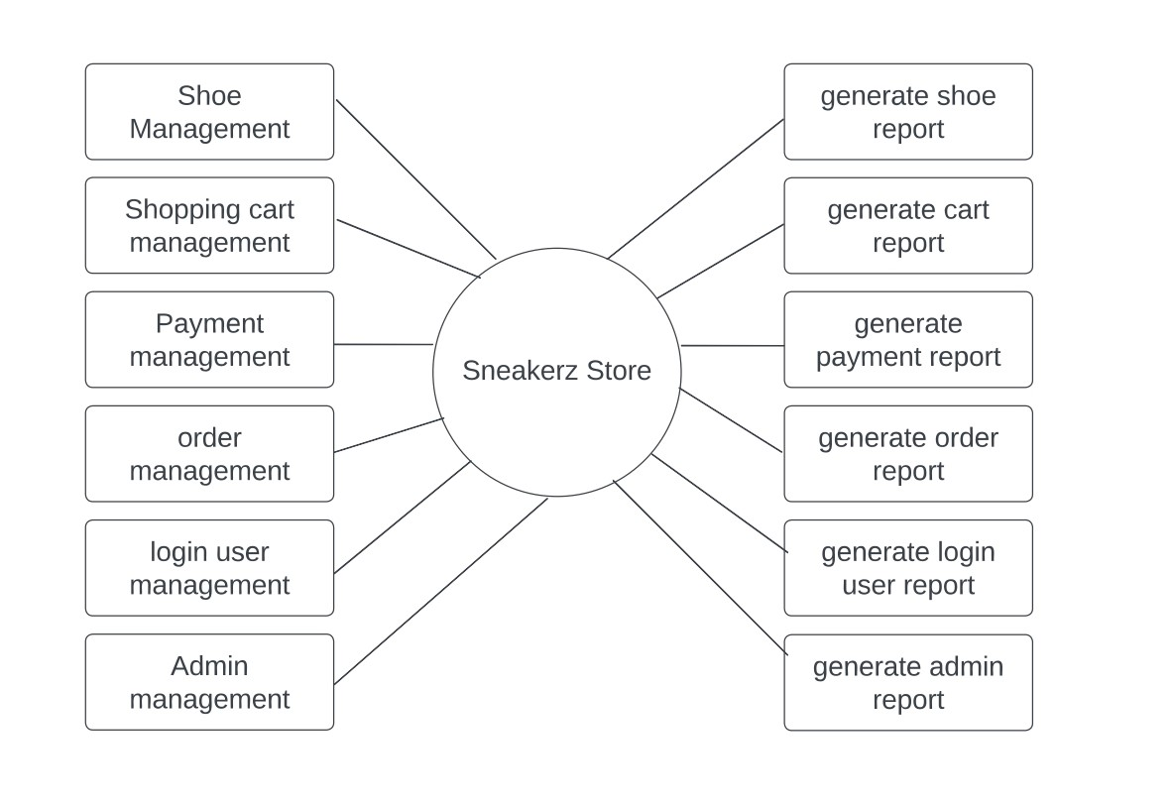

* **DFD-2 Diagram**

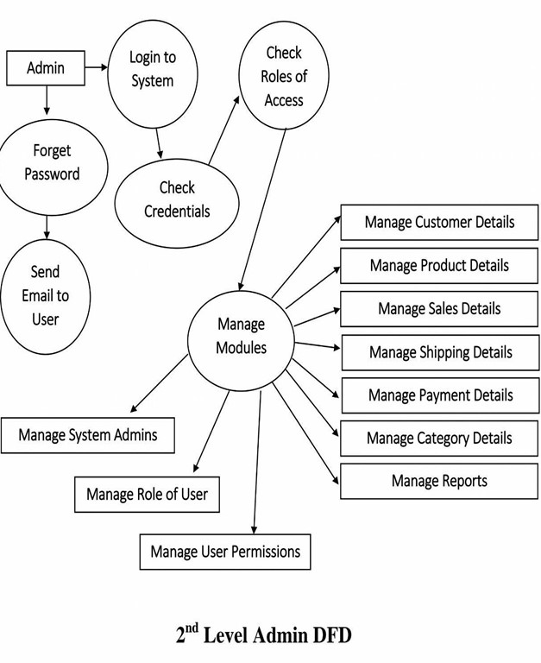

# 

* **Use Case Diagram**

# 

* **E-R Diagram**

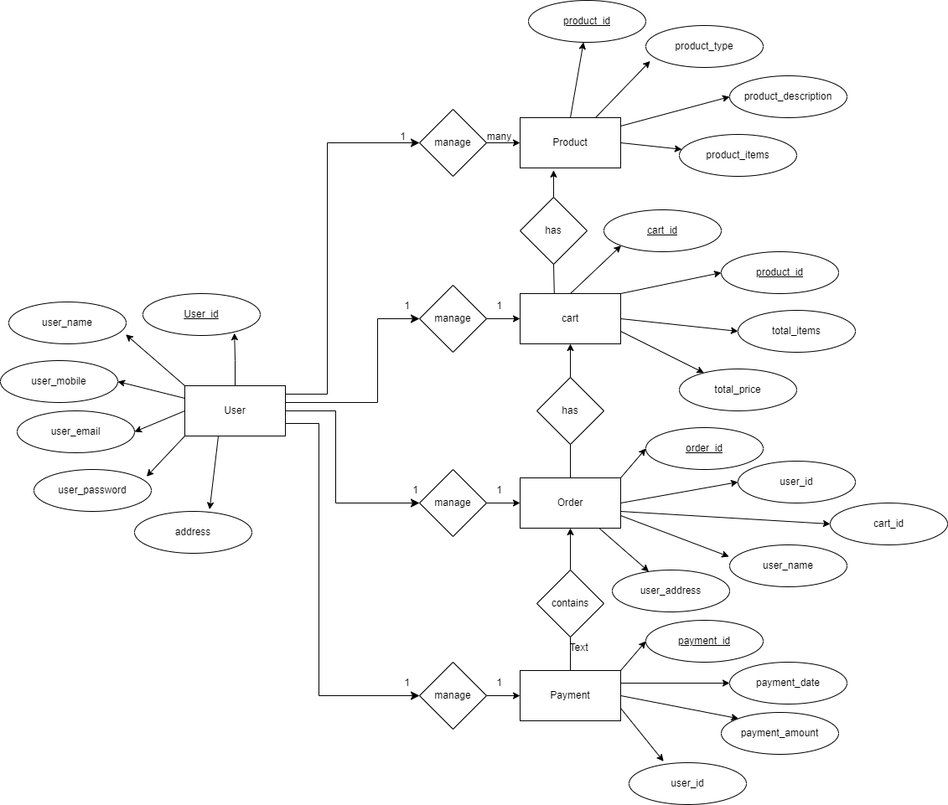

* **Class Diagram**

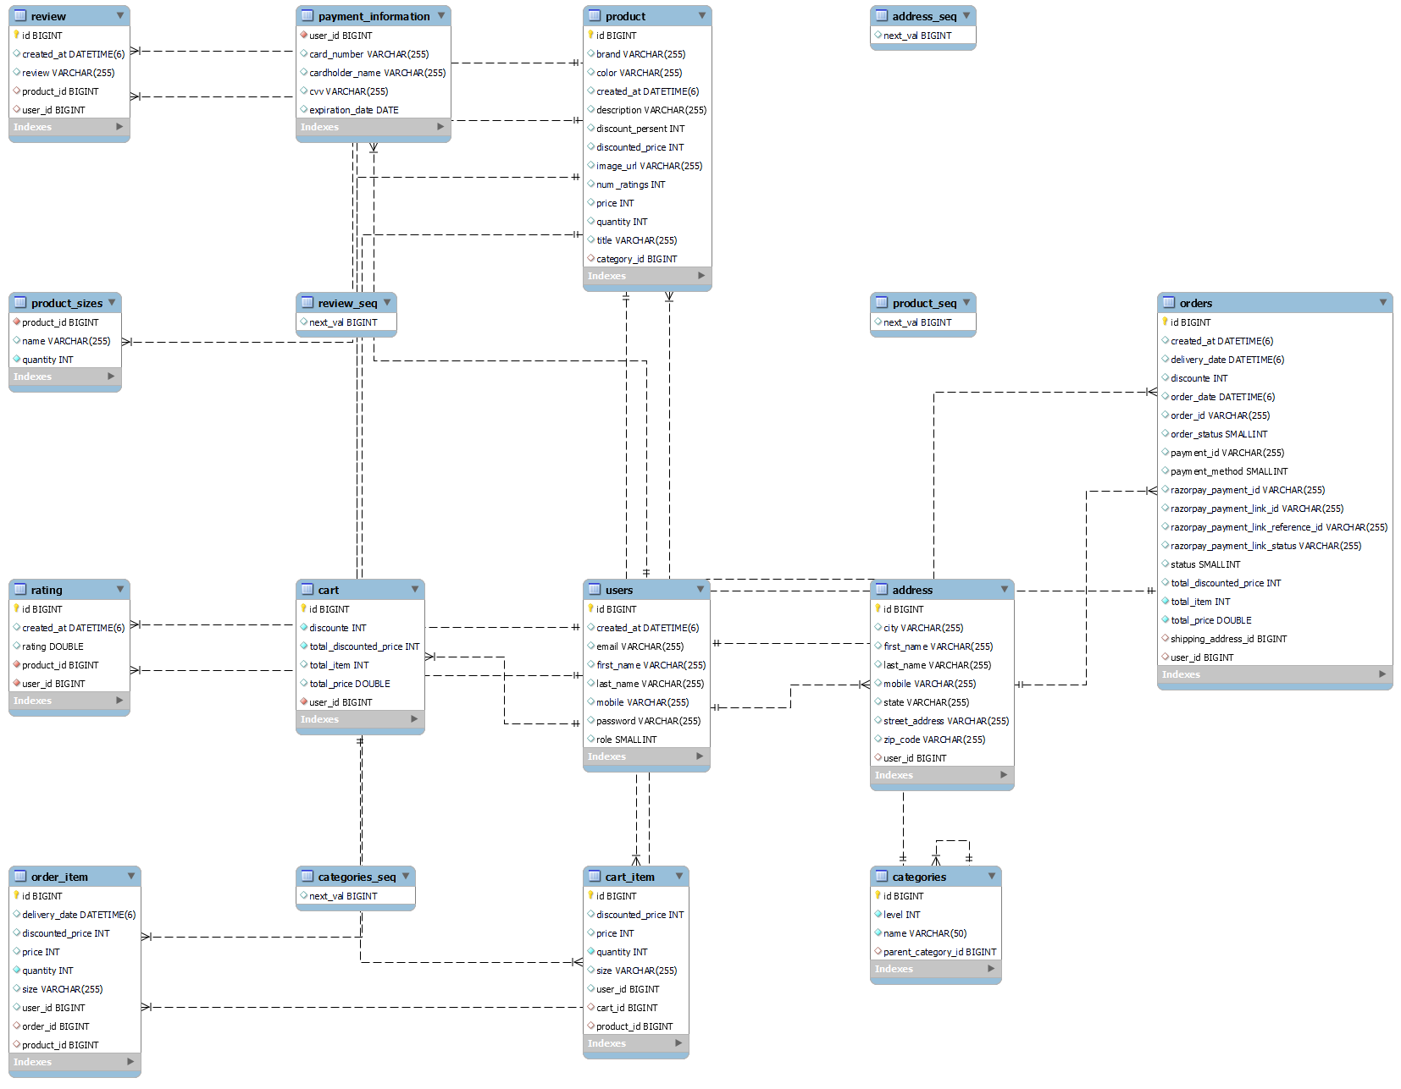

* **Sequence Diagram**

# 

# **TABLE STRUCTURE**

**User:**

|  |  |  |  |  |  |
| --- | --- | --- | --- | --- | --- |
| Field | Type | Null | Key | Default | Extra |
| id | bigint | NO | PRI | NULL | auto_increment |
| created at | datetime (6) | YES |  | NULL |  |
| email | varchar (255) | YES |  | NULL |  |
| first_name | varchar (255) | YES |  | NULL |  |
| last name | varchar (255) | YES |  | NULL |  |
| mobile | varchar (255) | YES |  | NULL |  |
| password | varchar (255) | YES |  | NULL |  |
| role | smallint | YES |  | NULL |  |

**product:**

|  |  |  |  |  |  |
| --- | --- | --- | --- | --- | --- |
| Field | Type | Null | Key | Default | Extra |
| id | bigint | NO | PRI | NULL |  |
| brand | varchar (255) | YES |  | NULL |  |
| color | varchar (255) | YES |  | NULL |  |
| created_at | datetime(6) | YES |  | NULL |  |
| description | varchar(255) | YES |  | NULL |  |
| discount_persent | int | YES |  | NULL |  |
| discounted_price | int | YES |  | NULL |  |
| image_url | varchar (255) | YES |  | NULL |  |
| num_ratings | int | YES |  | NULL |  |
| price | int | YES |  | NULL |  |
| quantity | int | YES |  | NULL |  |
| title | varchar (255) | YES |  | NULL |  |
| category_id | bigint | YES | MUL | NULL |  |

**address:**

|  |  |  |  |  |  |  |
| --- | --- | --- | --- | --- | --- | --- |
| Field |  | Type | Null | Key |  | Default Extra |
| id |  | bigint | NO | PRI |  | NULL |
| city |  | varchar (255) | YES |  |  | NULL |
| first_name |  | varchar (255) | YES |  |  | NULL |
| last_name |  | varchar (255) | YES |  |  | NULL |
| mobile |  | varchar (255) | YES |  |  | NULL |
| state |  | varchar (255) | YES |  |  | NULL |
| street_address |  | varchar (255) | YES |  |  | NULL |
| zip_code |  | varchar (255) | YES |  |  | NULL |
| user id |  | bigint | YES | MUL |  | NULL |

**cart:**

|  |  |  |  |  |  |
| --- | --- | --- | --- | --- | --- |
| Field | Type | Null | Key | Default | Extra |
| id | bigint | NO | PRI | NULL | auto increment |
| discounte | int | NO |  | NULL |  |
| total_discounted_price | int | NO |  | NULL |  |
| total_item | int | YES |  | NULL |  |
| total_price | double | YES |  | NULL |  |
| user id | bigint | NO | MUL | NULL |  |

**payment:**

|  |  |  |  |  |  |  |
| --- | --- | --- | --- | --- | --- | --- |
| Field | Type | Null |  | Key |  | Default Extra |
| user id | bigint | NO |  | MUL |  | NULL |
| card_number | varchar (255) | YES |  |  |  | NULL |
| cardholder_name | varchar (255) | YES |  |  |  | NULL |
| CVV | varchar (255) | YES |  |  |  | NULL |
| expiration_date | date | YES |  |  |  | NULL |

**order:**

|  |  |  |  |  |
| --- | --- | --- | --- | --- |
| Field | Туре | Null | Key | Default Extra |
| id | bigint | NO | PRI | NULL auto increment |
| created_at | datetime (6) | YES |  | NULL |
| delivery_date | datetime (6) | YES |  | NULL |
| discounte | int | YES |  | NULL |
| order_date | datetime (6) | YES |  | NULL |
| order_id | varchar (255) | YES |  | NULL |
| order_status | smallint | YES |  | NULL |
| payment_id | varchar (255) | YES |  | NULL |
| payment method | smallint | YES |  | NULL |
| razorpay_payment_id ? | varchar (255) | YES |  | NULL |
| razorpay_payment_link_id | varchar (255) | YES |  | NULL |
| razorpay_payment_link_reference_id | varchar (255) | YES |  | NULL |
| razorpay_payment_link_status | varchar (255) | YES |  | NULL |
| status | smallint | YES |  | NULL |
| total_discounted_price | int | YES |  | NULL |
| total_item | int | NO |  | NULL |
| total_price | double | NO |  | NULL |
| shipping_address_id | bigint | YES | MUL | NULL |
| user_id | bigint | YES | MUL | NULL |

# **SCREENSHOTS**

# **HOME PAGE**

# 

# **SIGN UP**

# 

# **LOGIN**

# 

# **PRODUCT DETAILS**

# 

# **ADD TO CART**

# 

# **ORDER PROCESSING**

# 

# **ORDER SUMMARY**

# 

# **CONCLUSION**

Our project is only a humble venture to satisfy the needs to manage their project work. Several user-friendly coding has also adopted. This package shall prove to be a powerful package in satisfying all the requirements of the school. The objective of software planning is to provide a frame work that enables the manger to make reasonable estimates made within a limited time frame at the beginning of the software project and should be updated regularly as the project progresses.

* A description of the background and context of the project and its relation to work already done in the area.
* Made statement of the aims and objectives of the project.
* The description of Purpose, Scope, and applicability.
* We define the problem on which we are working in the project.
* We describe the requirement Specifications of the system and the actions that can be done on these things.
* We understand the problem domain and produce a model of the system, which describes operations that can be performed on the system.
* We included features and operations in detail, including screen layouts.
* We designed user interface and security issues related to system.
* Finally, the system is implemented and tested according to test cases.
* **Future Scope**

In a nutshell, it can be summarized that the future scope of the project circles around maintaining information regarding:

We can add printer in future.

We can give more advance software for Online Shoes Store including more facilities

We will host the platform on online servers to make it accessible worldwide

Integrate multiple load balancers to distribute the loads of the system

Create the master and slave database structure to reduce the overload of the database queries.

Implement the backup mechanism for taking backup of codebase and database on regular basis on different servers.

The above-mentioned points are the enhancements which can be done to increase the applicability and usage of this project. Here we can maintain the records of Customer and Order. Also, as it can be seen that now-a-days the players are versatile, i.e. so there is a scope for introducing a method to maintain the Online Shoes Store. Enhancements can be done to maintain all the Customer, Order, Shoes, Payment, Payment.

We have left all the options open so that if there is any other future requirement in the system by the user for the enhancement of the system then it is possible to implement them. In the last we would like to thanks all the persons involved in the development of the system directly or indirectly. We hope that the project will serve its purpose for which it is develop there by underlining success of process.

# **REFERENCES**

* <https://reactjs.org/docs/getting-started.html>
* <https://docs.spring.io/spring-boot/docs/current/reference/htmlsingle/>
* <https://developer.mozilla.org/en-US/docs/Web/JavaScript>
* <https://docs.oracle.com/en/java/>
* <https://dev.mysql.com/doc/>
* <https://www.eclipse.org/documentation/>
* https://code.visualstudio.com/docs/